**React is extremely popular, declarative, component-based, state-driven JavaScript library for building user interfaces created by Facebook.**

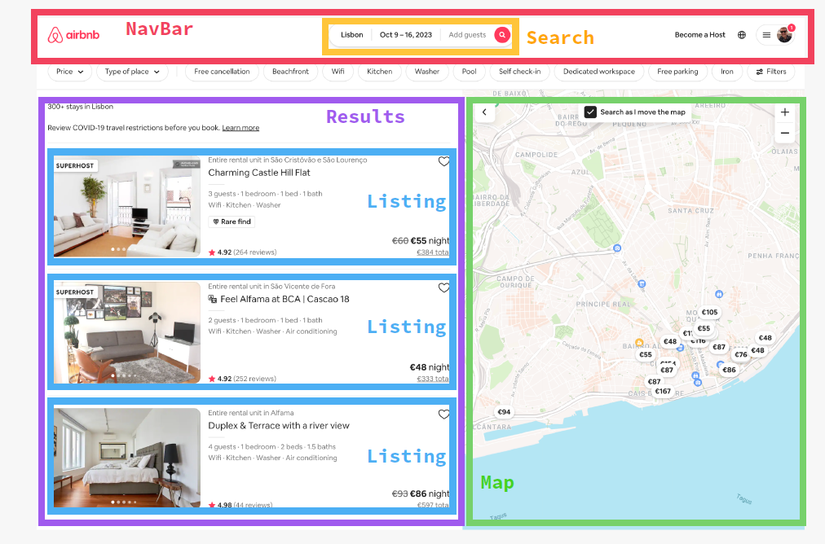

**Based on Components**

Components are the building blocks of user interfaces in React. We build complex UIs by building and combining multiple components.

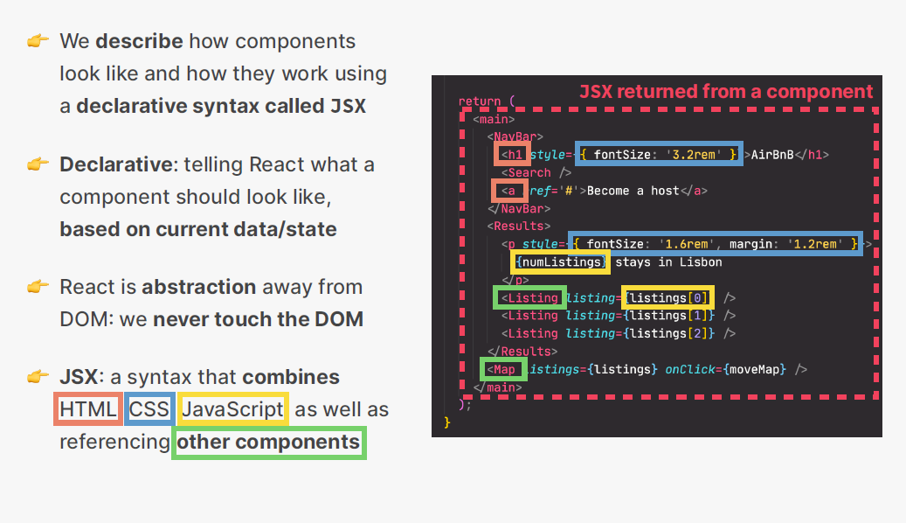

**Imperative Approach**

const element = document.createElement('p');

element.innerHTML = ` Hello, { name }! `;

document.body.appendChild(element);

**Declarative Approach**

const Greet = ({ name })=> <p> Hello, { name }! </p>

**State Driven**

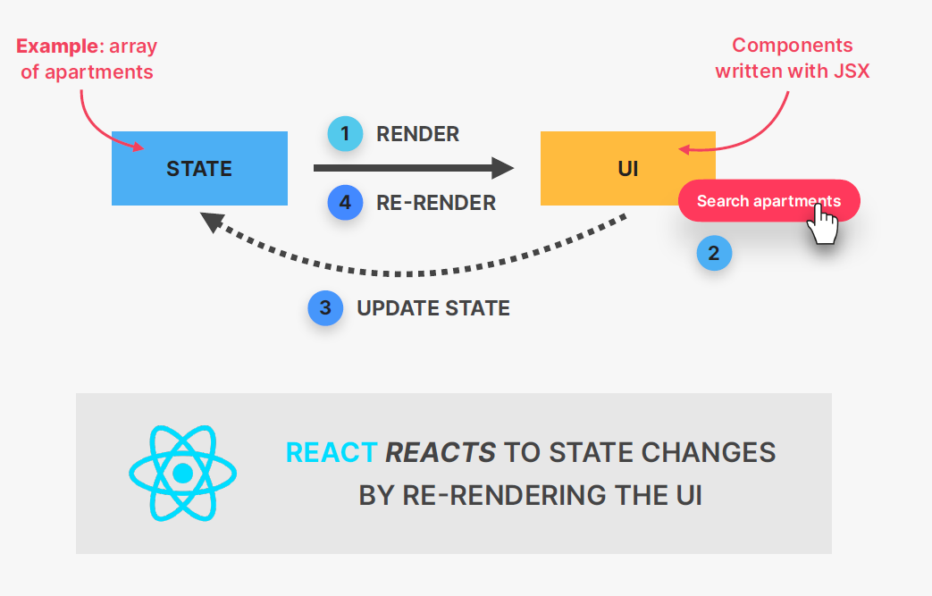

**JavaScript Library**

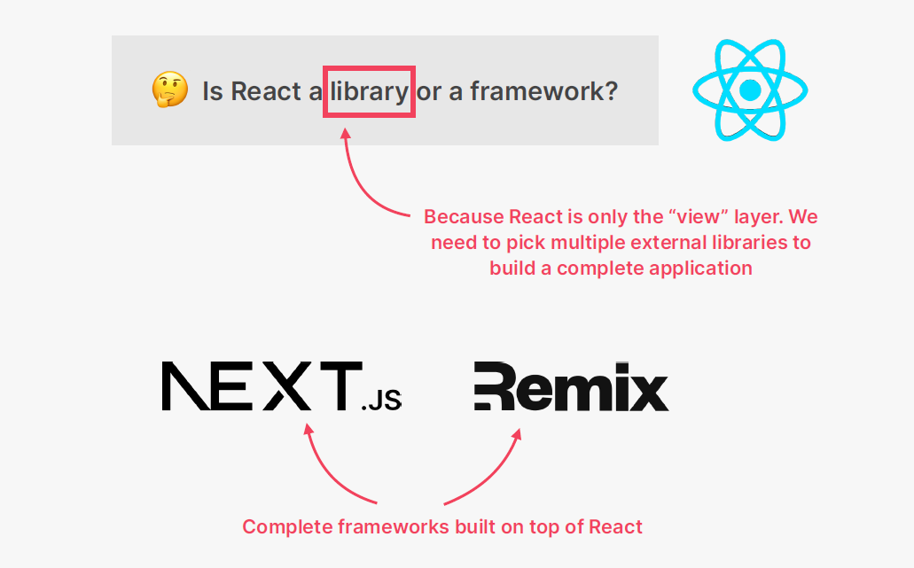

**Extremely Popular**

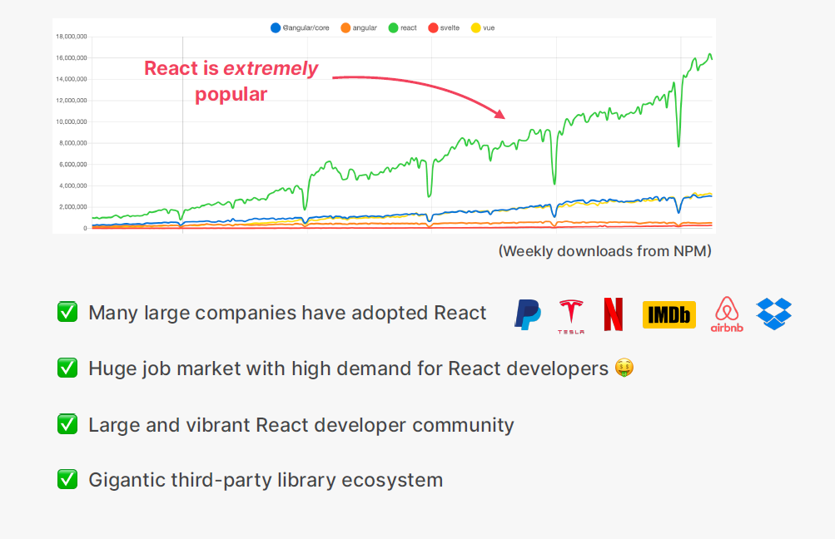

**Created by Facebook**

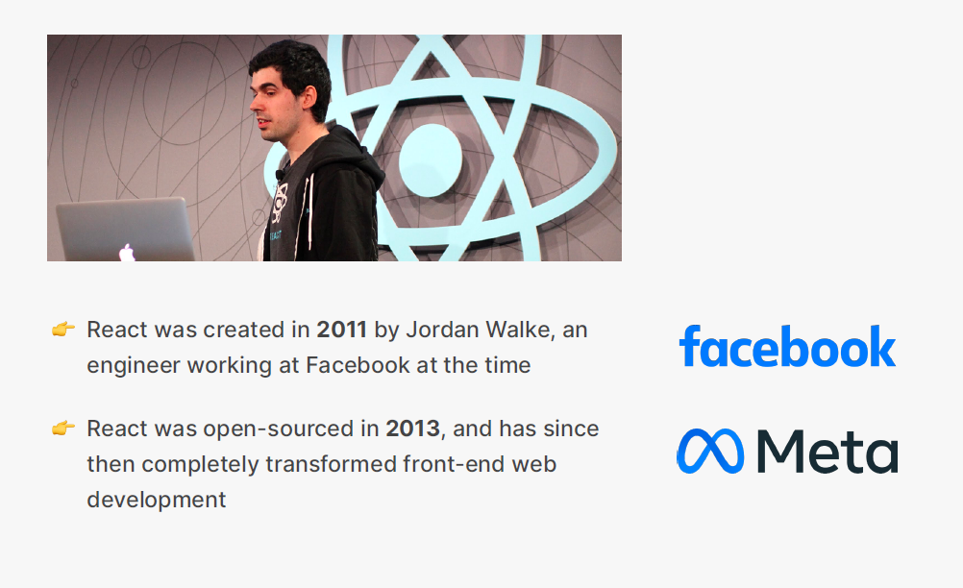

**Do you find it helpful?**

Let me know down in the comments.



[](https://www.linkedin.com/in/anubhav-gupta-b68946132/)

Click To Follow For More On LinkedIN